

**Carrier Xpower Gold 42CVSR022 703 2 Ton**

**Rs. 275,700/-**

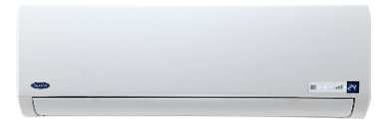

**Product Features**

* concealed LED display
* Intelligent airflow
* precise system control technology
* friendly referigerant R410a
* auto restart after power restored

**Specification**

**Type** Wall Mounted Split AC

**Cooling (Btu/h)** 51000

**Voltage (V)** 220-240

**Power Input (W)** 4600

**EER (Btu/W-h-W/W)** 6.1-3.4